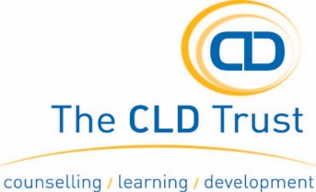
SELF-REFERRAL OVER 18
CONFIDENTIAL

This referral is made into The CLD Trust’s Talking Therapies. By completing this form or agreeing to a referral you are consenting to your information being processed by The CLD Trust. This information will be used for the purpose of accessing support. Your details will be processed and stored electronically and in a paper file in accordance with the guidance set out in the General Data Protection Regulations (GDPR). Further information about this will be discussed at your first session.

YOUR DETAILS
NAME: | DOB: | AGE:
GENDER MALE: FEMALE OTHER PREFER NOT TO SAY
ADDRESS |  | POSTCODE:
EMAIL: | LANDLINE | MOBILE:
PREFERRED METHOD OF CONTACT: TEL: EMAIL: LETTER
Please tell us about your concerns and how these are impacting on you.

Is there anything in your life that is helping or making the situation worse?

RISK:
YES NO

Have you ever had suicidal thoughts?

Have you ever attempted to take your own life?

Do you feel you are at risk to yourself or any other person?

Have you, had any previous experience of talking therapies? Yes No

Details:

ADDITIONAL INFORMATION

Details of any current medication, please state?

Do you have a disability, please state?

Do you require disabled access?

GP NAME: TEL NO:

ADDRESS:

Are you receiving support from anywhere else?

Thank you – please email this form to info@thecldtrust.org or post to The CLD Trust, 20 East Street, Hereford HR1 2LU

